ANKANI BALAJI
ankanibalajioffcial@gmail.com
Developer Assessment Submission
Technology Stack
Python • Flask • Google Gemini • FAISS • LangChain • Bootstrap
Submission Date
22 June 2026
VertexDoc AI
Intelligent PDF Chat Assistant using Retrieval Augmented Generation (RAG)

Author
Developed by
Ankani Balaji
Email: ankanibalajioffcial@gmail.com
GitHub: https://github.com/Ankani-Balaji/Vertex_Doc_AI
VertexDoc-ai: https://vertexdoc-ai.onrender.com
Technology Stack
Python
Flask
Google Gemini
LangChain
FAISS
Bootstrap

Table of Contents

1. Introduction
2. Problem Statement
3. Project Objectives
4. Technology Stack
5. System Architecture
6. Application Workflow
7. Project Structure
8. Module Explanation
9. Features
10. Challenges & Solutions
11. Testing
12. Deployment
13. Future Enhancements
14. Conclusion

Introduction
Project Overview:
VertexDoc AI is an intelligent document assistant designed to simplify the process of understanding and interacting with PDF documents. Instead of manually reading long documents, users can upload a PDF and communicate with it through natural language.
The application extracts text from uploaded files, generates semantic embeddings, stores them inside a FAISS vector database, retrieves relevant document chunks, and finally generates accurate responses using Google Gemini.
Unlike traditional chatbots, the application follows a Retrieval Augmented Generation (RAG) approach, ensuring that responses are grounded in the uploaded document instead of relying on external knowledge.
The project demonstrates modern AI application development using Flask and modular service architecture while maintaining a clean and scalable codebase.

Problem Statement
Many users spend considerable time searching through lengthy PDF documents to locate important information.
Traditional search methods rely on keyword matching and often fail to understand context, resulting in inefficient document exploration.
An AI-powered document assistant can significantly improve productivity by understanding user questions and retrieving relevant information directly from the document.
Objectives:
The primary objectives of the project are:
- Build a web application using Flask
- Allow users to upload PDF documents
- Extract readable text from uploaded PDFs
- Generate intelligent document summaries
- Create semantic vector embeddings
- Implement Retrieval Augmented Generation (RAG)
- Enable conversational interaction with uploaded documents
- Export conversation history

Technology Stack
Backend: Python, Flask Framework
Artificial Intelligence: Google Gemini API
Retrieval System: Retrieval Augmented Generation (RAG)
Vector Database: FAISS (Facebook AI Similarity Search)
Embedding Model: sentence-transformers/all-MiniLM-L6-v2
PDF Processing: PyPDF2
Frontend: HTML, CSS, Bootstrap, JavaScript
Additional Libraries: LangChain, ReportLab, python-dotenv

System Architecture
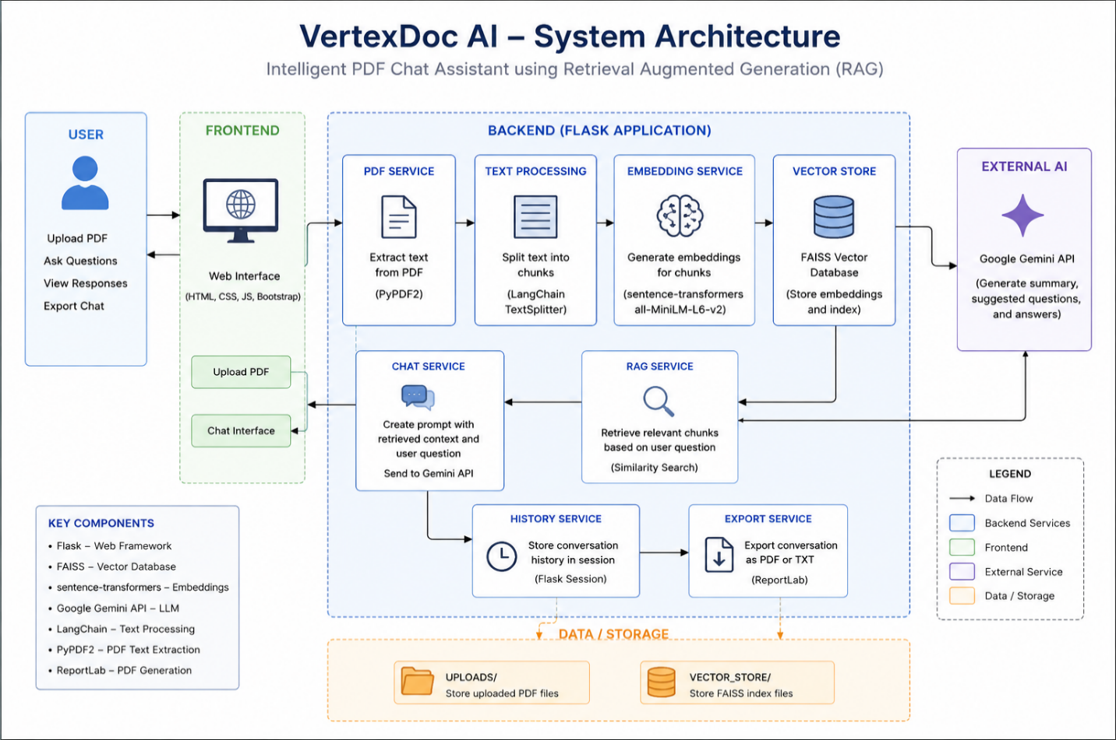
The application follows a modular architecture where each service performs a single responsibility.
The uploaded PDF is processed by PDFService, converted into text, split into chunks, transformed into embeddings, and stored in FAISS.
When a user asks a question, the system retrieves the most relevant chunks and sends only those chunks to Google Gemini, ensuring context-aware and document-grounded responses.
Application Workflow
User Uploads PDF
↓
PDF Text Extraction
↓
Text Chunking
↓
Embedding Generation
↓
FAISS Vector Storage
↓
User Question
↓
Similarity Search
↓
Relevant Context
↓
Google Gemini
↓
Final Answer
User Interface
Home Page:
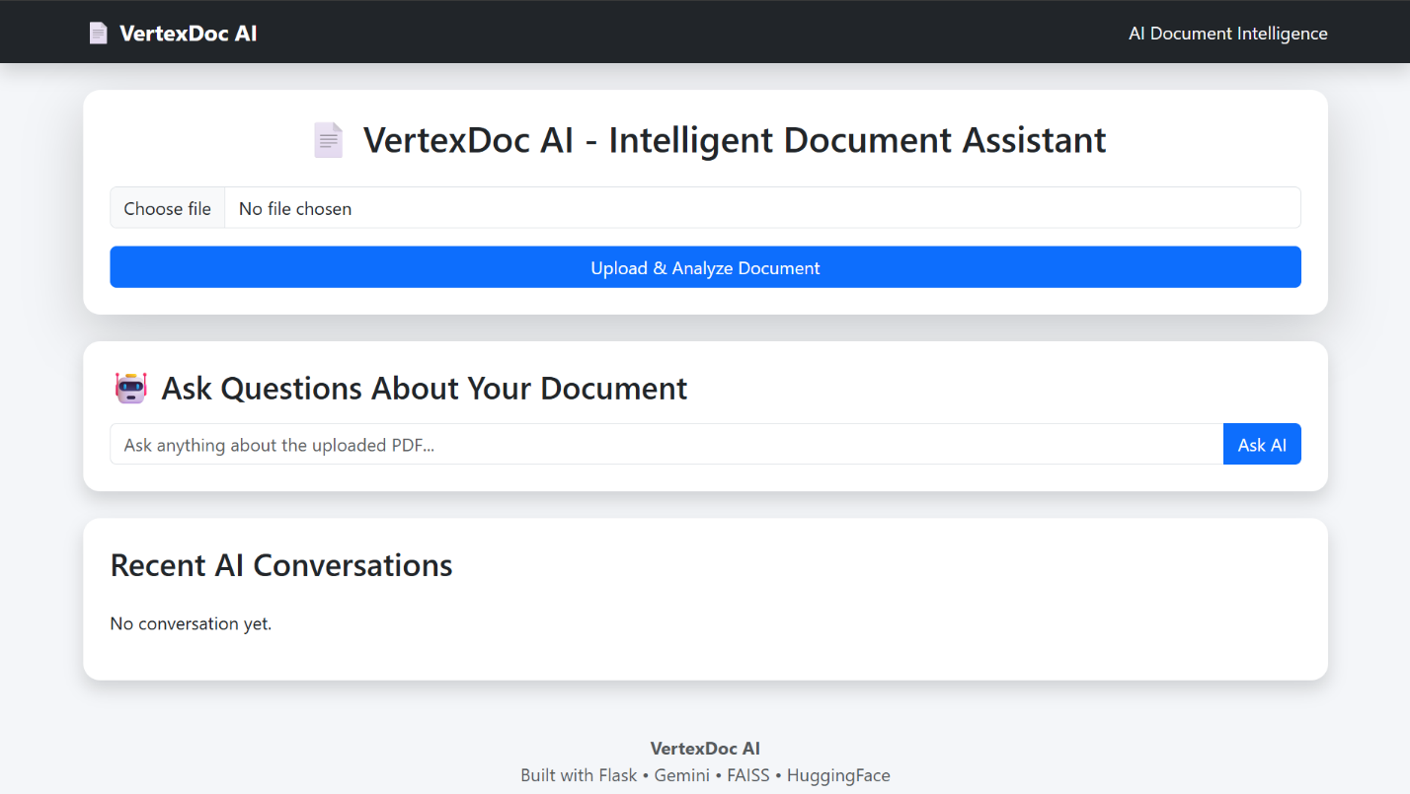

The home page provides a clean interface where users can upload a PDF document and interact with the AI assistant.

PDF Upload & Processing

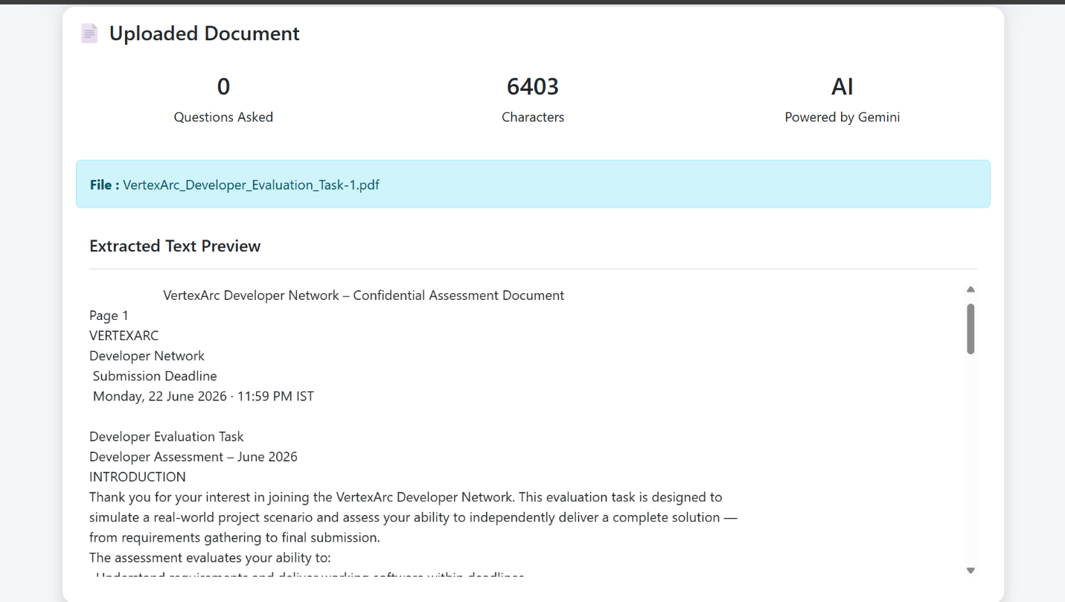

After uploading a document, the system extracts text, generates statistics, and prepares the document for semantic search.

Suggested Questions & Chat

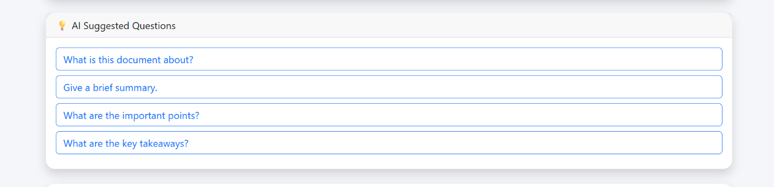

The application automatically generates context-aware questions and allows users to ask custom queries.

Project Structure
vertex-doc-ai/
│
├── app.py
├── config.py
├── requirements.txt
├── routes/
│ upload.py
│ chat.py
│
├── services/
│ pdf_service.py
│ rag_service.py
│ summary_service.py
│ question_service.py
│ chat_service.py
│ export_service.py
│
├── templates/
│ base.html
│ index.html
│
├── static/
│ css/
│ js/
│
├── uploads/
├── vector_store/
└── README.md

The project follows a service-oriented architecture, improving maintainability and scalability.

Module Explanation
PDF-Service:
Responsible for extracting text from uploaded PDF documents.
Summary-Service:
Generates concise AI-powered summaries using Google Gemini.
Question-Service:
Automatically creates suggested questions based on document content.
RAG-Service:
Splits text into chunks, generates embeddings, stores vectors in FAISS, and retrieves relevant information.
Chat-Service:
Uses retrieved document context to generate accurate answers through Google Gemini.
Export-Service:
Exports conversation history as TXT and PDF files.
Features Implemented
✔ PDF Upload
✔ Automatic Text Extraction
✔ AI Summary Generation
✔ AI Suggested Questions
✔ Retrieval Augmented Generation
✔ Semantic Similarity Search
✔ Document Chat Interface
✔ Session-based Conversation History
✔ Export Conversation as TXT
✔ Export Conversation as PDF
✔ Responsive Bootstrap User Interface
Challenges & Solutions
Challenge 1
Large PDF documents cannot be directly processed efficiently.
Solution
Implemented text chunking and FAISS vector indexing.

Challenge 2
AI models may generate hallucinated responses.
Solution
Implemented Retrieval Augmented Generation (RAG) so that answers are generated only from retrieved document context.

Challenge 3
Google Gemini free-tier quota limitations.
Solution
Added exception handling and fallback messages to provide a graceful user experience.
Testing & Validation
The following functionalities were successfully tested:
Functionality | Result
PDF Upload | ✅ Passed
Text Extraction | ✅ Passed
AI Summary Generation | ✅ Passed
AI Suggested Questions | ✅ Passed
Semantic Search | ✅ Passed
Document Chat | ✅ Passed
Conversation History | ✅ Passed
TXT Export | ✅ Passed
PDF Export | ✅ Passed
Error Handling | ✅ Passed

Deployment
The application has been successfully deployed on a cloud hosting platform using Render.
Deployment includes:
- Flask application server
- Static asset serving
- PDF upload functionality
- AI-powered document summarization
- Retrieval-Augmented Generation (RAG) pipeline
- Interactive document chat interface
- Export functionality for TXT and PDF
Environment variables such as API keys and secret keys are securely managed through Render Environment Variables, ensuring that sensitive information is never exposed in the source code.
The deployed application demonstrates that the project is production-ready and accessible through a public URL for evaluation.

Future Enhancements
The following improvements can further enhance the application:
• OCR support for scanned PDFs
• Multi-document knowledge base
• User authentication and authorization
• Persistent vector database storage
• Cloud-native deployment optimization
• Real-time collaborative document analysis
• Conversation memory across sessions
• Support for multiple LLM providers
Conclusion
VertexDoc AI successfully demonstrates the practical implementation of an intelligent document assistant powered by Retrieval-Augmented Generation (RAG).
By integrating Flask, Google Gemini, Hugging Face Embeddings, and FAISS Vector Search, the system enables users to upload PDF documents, generate AI-powered summaries, ask context-aware questions, receive document-grounded answers, and export conversation history.
The modular architecture, service-oriented design, and responsive user interface make the application maintainable, scalable, and suitable as a foundation for future AI-powered document intelligence solutions.
The successful cloud deployment further validates the project's real-world applicability and production readiness.

